- My Sites
About WordPress
- AMP
- Search
- Howdy, Anant Panchal
Log Out
Skip to content
- Blog Home

- Data Science
- Categories
- Free Courses
Search for:

Why you should Learn Python in 2023? – Learn from Python Experts
Free Python courses with 57 real-time projects - Learn Python
Why Learn Python? – Reasons for its Hype in Programming World
IT industry moves at a quick pace and with each coming day, you get to hear about a new technology or programming language that is emerging and people strengthening it.
This becomes overwhelming for the beginners who are confused about which programming language would be well suited and fit for them.
But, don’t worry, DataFlair has a plan for you. Let’s start the article with a fun fact.
The term “Python” relating to a programming language is more popular than the famous star “Kim Kardashian”. You can confirm this fact by comparing them in Google Trends.

Why Learn Python?
The first question that is probably coming in your mind is “Why specifically learn Python?”
Well, the answer to this question is quite simple. Think about the factors you would like to include in a programming language.

1. Learnability
Is it gonna be hard? No! Not at all.
Python is the first language of choice in many universities and even kids in school are learning to program with Python.
The Python language was designed to ease the programming with English like syntax, it cut down all the low-level tasks and provided a high-level abstraction for you to perform any tasks you want.
Python is a great option for both novice and seasoned developers because of its clear, concise, and simple grammar. Its emphasis on code readability places a higher value on human comprehension than sophisticated syntax, resulting in more effective and maintainable code.

2. Increased Productivity
After learning a programming language, what are you planning to do?
Do you want to build applications, web services, exciting games, automate a repetitive task, perform complex scientific or numeric calculations or gather insights from some data?
Python has got you covered with everything. It’s one of the most productive languages out there.

3. High Paying Salaries
Learning Python is the best investment you can make today.
Python developers are paid highest especially in the domain of web development, machine learning, and data science.
The salaries can range from $70,000 to $1,50,000 depending on the location and your experience in the industry.
There is a lot of demand for Python developers in the IT industry so you won’t have any trouble finding Python jobs in the market.
Another Fun Fact – Python is #2 on the Tiobe index, and it has been the Programming language of the year many times including 2022.
According to our predictions, it will probably be the programming language of the year in 2023 as well.

4. Automation and Scripting
Python is a great option for automation and scripting activities due to its simplicity and use. It is frequently used to manage system administration, automate menial activities, and write short scripts.

5. Web programming
Python provides a number of frameworks, such Django and Flask, that make web programming easier. These frameworks make it easier to create online apps, which is why web developers choose them.

Python Applications
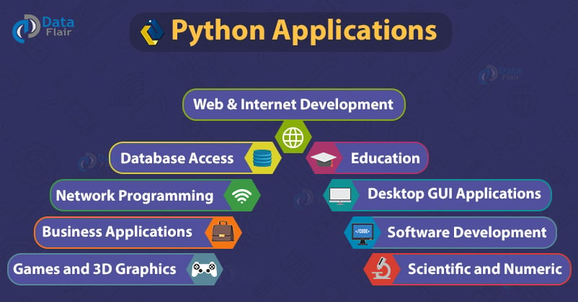
There is no limit to the things you can do with Python but here we will be describing some of the most important real-world applications of Python.

1. Web Development
Python is a good choice for rapid development of web applications.
With many frameworks like Django, Pyramid, and Flask, Python allows you to build web apps with great speed.
Python is used on the server-side of web development, you can use Python to interact with the database and build Rest API services.

2. Data Science
Earlier Python was mostly used for building applications and writing scripts to automate tasks but now a whole new trend of data science has uplifted Python even more.
Data science people are heavily dependent on Python because of its advantages like simplicity, great community, and capabilities to compute huge calculations with ease.
Python libraries and frameworks that are popular in the data science field are:
- Pandas (Data analysis)
- Numpy (Numeric and scientific calculations)
- Matplotlib, Seaborn (Data visualizations)
- Scikit-learn (Machine learning)
- Tensorflow, Keras (Machine and Deep learning )

3. Artificial Intelligence
The near future will be the era of artificial intelligence.
Computers and machines were used to perform mathematical calculations at very high speeds but now many big organizations and researchers are working on building intelligent systems that can perform tasks as a human would.
To some extent, machines are capable enough to understand human emotions and their natural language.
They can mimic certain actions performed by humans that were not possible before. Again Python is popular for building AI systems.
Some Python libraries that are used for building intelligent systems are listed below:
- NLTK – Natural language toolkit for Natural language processing
- OpenCV – Open-source computer vision library
- Keras – Deep learning library
- Microsoft cognitive toolkit – Deep learning framework

4. Automation
Python can make life easier by automating many tasks like scraping a website to collect data, automating test cases in software development areas, to automating mundane office tasks.
Python can easily access and read all types of files which opens up an opportunity to save a lot of time by automating repetitive tasks.
The frameworks or library used for automation are:
- Robot framework
- PyTest
- Selenium Python
- PyUnit
Python is being used in diverse fields remarkably and it shows no signs of stopping.
It is safe to conclude that Python will stick for the long run in this ever-changing and evolving IT industry.

How to Learn Python?
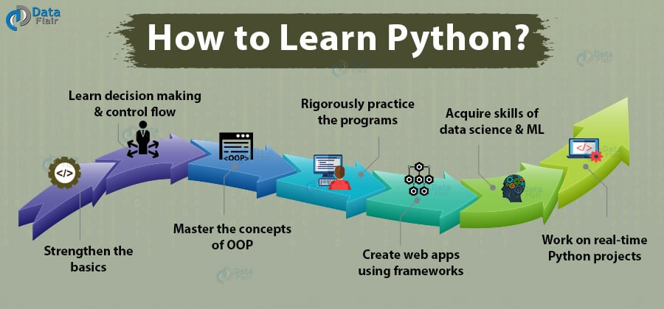
Let’s take another step and make a plan for yourself on how you can learn Python effectively.
The seven sins you should commit to Learn Python:

Step 1: Strengthen the basics
It all starts with the beginning, understand the terms and concepts related to programming.
So dive right in by installing Python on your machine and start learning the basics syntax, variables and data types of Python programming language.

Step 2: Learn Decision making and Control flow
After getting familiar with the basics, learn about how you can make decisions in a programming language.
There are different methods like if and else statements that allow you to make decisions according to a condition.
Loops are also an important part of all programming languages.
You can easily perform a repetitive task using loops and learn the concept by implementing different types of loops like For loop, while loop and nested loops.

Step 3: Master the Object-oriented Programming (Oops)
Object-oriented programming is an approach of solving all problems by thinking about the real-world entities in the form of objects and classes.
Oops are beneficial when building large scale applications, it helps us in writing clean code by reusing the usable components. They are also easy to maintain.

Step 4: Practise programs
You will never be a good programmer until you have spent hours solving different types of problems. So don’t forget to practice!

Step 5: Create Web Apps using Frameworks
In the web development environment, Python is used on the server-side programming of web applications.
We use HTML, CSS, and JavaScript on the front side to define the look of our website along with transitions and animations.
The most popular Python frameworks for web development are Django and Flask. These frameworks offer the rapid development of applications.
So you can choose any one of them and make a small project by creating a web app with basic CRUD operations.

Step 6: Acquire Skills of Machine learning and Data science
The world of data science and machine learning heavily depends on Python. You can boost your profile by acquiring the skills of a data scientist or a machine learning engineer.
Analyze the data using the Pandas library, perform numeric calculations using Numpy library, build machine learning models using scikit-learn and visualize data with libraries like matplotlib or seaborn.

Step 7: Work on Python Projects
Create a list of Python project ideas and build something from all the things you have learned. Make a major project by integrating everything.
You can build a machine learning model and integrate it with a website by providing some form of service to the users.
Get ready to work on the real-time Python projects with source code:
- Fake News Detection Python Project
- Parkinson’s Disease Detection Python Project
- Speech Emotion Recognition Python Project
- Breast Cancer Classification Python Project
- Age and Gender Detection Python Project
- Chatbot Python Project
- Driver Drowsiness Detection Python Project
- Traffic Signs Recognition Python Project
- Image Caption Generator Python Project

Summary
Python is constantly rising in the industry and proved itself worthy to be known as one of the top programming languages.
Hope this article helped you in understanding why you should learn Python. So start now and give a boost to your career.

Python’s Future is even above the ‘C’ level!
Free Python courses with 57 real-time projects - Learn Python
Imagine everything that you are surrounded by is raw, unstructured, incomplete, vast and just Data! Python will definitely be there for your rescue!
Python is the Future and it will serve as a huge, reliable, effective and ready-to-use technology. What it can do for us? Well, it can play around with data, visualize the data, transform inputs into a numerical matrix, or actual machine learning and assessment.
All that needs to be done is to write the code — that would glue everything together. As simple as that!


What will be the Future of Python?
Laying some grounds on which we will define the future of Python.

How are we defining the popularity of programming language?
According to recent studies, Python showed 456-percent growth. Quite a number, isn’t it? In business terms — Netflix, IBM, Dropbox and hundreds more utilize Python as their success key!
If you want to explore Python more, you need to check how Netflix is using Python

How are we defining Python’s popularity in a specific field?
Python is and remains a stable programming language currently used not only by developers but it is considered great for deployment automation and web development. Non-developers when first introduced to the Python language and its ecosystem, also prefer it for doing data work.

Who is driving the growth till now and will drive it in the future?
The sudden rise of demand for python and every platform becoming a “python-oriented-platform”, isn’t everything just getting “pythonized”?
First of all, man’s life chasing point – money!
For future and present programmers, Python is becoming the first-choice language for learning it to get “actual jobs”. It is also being used for many purposes, from web development to mobile app development to data science. However, Data science is attracting the mob towards Python.
Secondly, Python’s serious versatility. Python is a multipurpose language used for various tasks, as seen above. “Pandas” is by far the fastest-growing Python package. Therefore it seems clear that the rise of data science is responsible for the growth of Python as “it’s” programming language.
Finally, Machine Learning. There is no special programming language dedicated to Machine Learning, but looking at the characteristics of each language that can do ML, choose the best that will fulfill their needs, Python. It is one of the most popular and the best languages for Machine Learning.

Python’s growth is for now!? or this growth has some Future!!??
Trends somehow define the need and needs definitely define the actual trends. There’s no doubt that Python is now in “the trend”. All thanks to its popularity and the helpful community, Python is really friendly. Since it is so easy to learn Python, you can start your python journey at this moment itself. That is not all, it is the way it lets developers express their thoughts in a simpler way, adds on to the “choose python!” thing.

Python in Robotics and Machine Learning
The use is not little but extensive. It is a gift to the systems originally written in C and C++ as it makes it easy to interface with Python. Anywhere that data analysis is required, Python and its diverse libraries shine.
At the end of the day, everyone is aware of how important machine learning is in the modern world. From moderating social networks to driving cars, trained neural networks are doing everything. The field has moved forward incredibly in recent years due to quickly increase in processing power. The potential for machine learning is vast, and not yet even close to fulfillment.

What has this got to do with Python?
A lot. While there are libraries designed to work with other popular languages, Python is in actuality language of machine learning. Notably, Google’s TensorFlow works primarily with Python. Almost every course on neural networks uses Python.
Machine learning as a skill is in greater demand every day. A good grasp of the Python programming language puts you in a leading position amongst others learning it from scratch.

Python being open source
Saying Python is free may not take your interest in it at first glance. After all, the language you decide to pursue, simply using it, doesn’t actually cost anything. Python is free as in ‘Open Source’. It is entirely Open Source and GPL compatible. Open-source software has already changed the world. Python’s being a perfect tool even takes the “no-strings-attached status” to complement its use.

Python is blooming
Over the years, Python has swept into the coding world and has managed to reach the top. The survey and job research in major countries calculated that over 40,000 jobs are entirely for python experienced developers. To add on, internet search tags are also higher for python only in those countries which helped it to make it to the top! It is no wrong in saying that Data science combined with python has the best career and future complementing each other and to new heights.
You must check the latest article on Python Career Opportunities

Conclusion
We’re going to see continuous growth in the scientific programming part of Python. So things that support the performance of Python as a language and its stability are going to continue to evolve. Beyond that, Python is a pretty powerful and solid language. Even if you stopped development today, Python is a good sewed up language.
Not trying to declare a war between language as to make a belief that Python’s the king. Whereas, it is crucial to understand that trends might be changing, and there’s room for discussion left for everyone. We live in a data-driven world and we’re really setting Python up for another 20 years of success and growth.
Hope you liked our Python Future article. Drop your feedback in the comment section, it means a lot to us. We recommend you to try this DataFlair’s Python Self-paced Training to become a master of Python.

Python Applications – Unleash the power of Python
Free Python courses with 57 real-time projects - Learn Python
Since the last few days, I was continuously thinking why Python is one of the most used programming languages on this planet? Then I started researching on it at different platforms, and can you guess what I found after my research?
Python is the most versatile language in the programming world, and it has applications in various domains. It helps us in taking care of our current programming task as well as lets us focus on the core functionality of Python programming languages.
Talking about this Python applications tutorial, it will help both beginners and intermediates in learning and polishing their coding skills.

Applications of Python
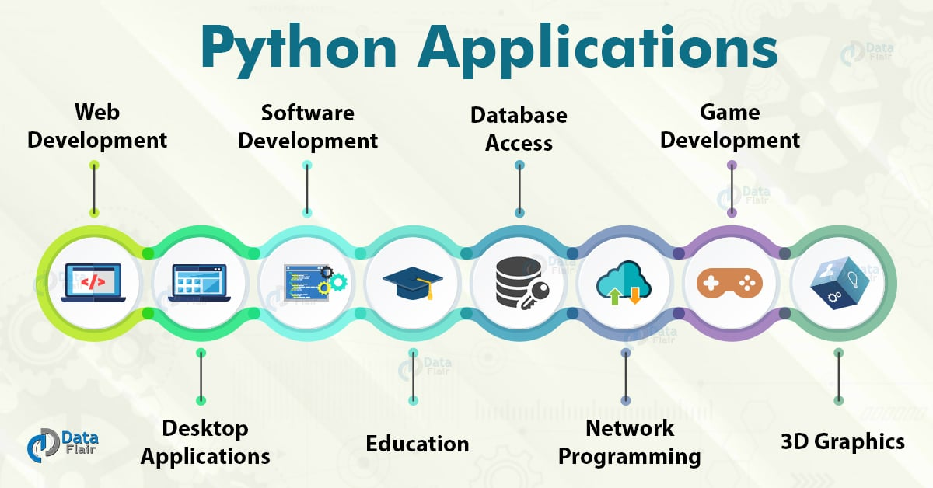
These are some real-world Python applications:
- Web and Internet Development
- Desktop GUI Applications
- Science and Numeric
- Software Development
- Education
- Database Access
- Network Programming
- Games and 3D Graphics
Let’s discuss each of them in detail:

1. Web and Internet Development
Python lets you develop a web application without too much trouble. It has libraries for internet protocols like HTML and XML, JSON, e-mail processing, FTP, IMAP, and easy-to-use socket interface. Yet, the package index has more libraries:
- Requests – An HTTP client library
- BeautifulSoup – An HTML parser
- Feedparser – For parsing RSS/Atom feeds
- Paramiko – For implementing the SSH2 protocol
- Twisted Python – For asynchronous network programming
We also have a gamut of frameworks available. Some of these are- Django, Pyramid. We also get microframeworks like flask and bottle. We’ve discussed these in our write-up on an Introduction to Python Programming. We can also write CGI scripts, and we get advanced content management systems like Plone and Django CMS.

2. Desktop GUI Applications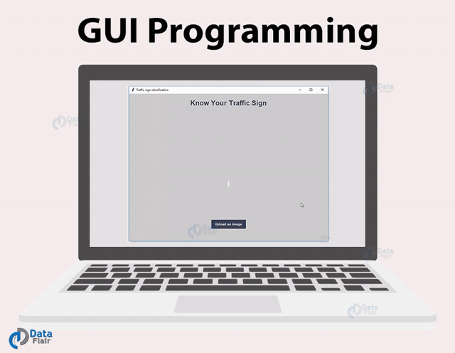
Most binary distributions of Python ship with Tk, a standard GUI library. It lets you draft a user interface for an application. Apart from that, some toolkits are available:
- wxWidgets
- Kivy – for writing multitouch applications
- Qt via pyqt or pyside
And then we have some platform-specific toolkits:
- GTK+
- Microsoft Foundation Classes through the win32 extensions
- Delphi

3. Science and Numeric Applications
This is one of the widespread applications of Python programming. With its power, it comes as no surprise that Python finds its place in the scientific community. For this, we have:
- SciPy – A collection of packages for mathematics, science, and engineering.
- Pandas– A data-analysis and -modeling library
- IPython – A powerful shell for easy editing and recording of work sessions. It also supports visualizations and parallel computing.
- Also, NumPy enables us to deal with complex numerical calculations.

4. Software Development
Software developers make use of Python as a support language. They use it for build-control and management, testing, and for a lot of other things:
- SCons – for build-control
- Buildbot, Apache Gump – for automated and continuous compilation and testing
- Roundup, Trac – for project management and bug-tracking.
- The roster of Integrated Development Environments

5. Education
Thanks to its simplicity, brevity, and large community, Python makes for a great introductory programming language. Applications of Python programming in education has a huge scope as it is a great language to teach in schools or even learn on your own.

6. Business
Python is also a great choice to develop ERP and e-commerce systems:
- Tryton – A three-tier, high-level, general-purpose application platform.
- Odoo – A management software with a range of business applications. With that, it’s an all-rounder and forms a complete suite of enterprise-management applications in-effect.

7. Database Access
With Python, you have:
- Custom and ODBC interfaces to MySQL, Oracle, PostgreSQL, MS SQL Server, and others. These are freely available for download.
- Object databases like Durus and ZODB
- Standard Database API

8. Network Programming
With all those possibilities, how would Python slack in network programming? It does provide support for lower-level network programming:
- Twisted Python – A framework for asynchronous network programming. We mentioned it in section 2.
- An easy-to-use socket interface

9. Games and 3D Graphics
Safe to say, this one is the most interesting. When people hear someone say they’re learning Python, the first thing they get asked is – ‘So, did you make a game yet?’
PyGame, PyKyra are two frameworks for game development with Python. Apart from this, we also get a variety of 3D-rendering libraries.
If you’re one of those game-developers, you can check out PyWeek, a semi-annual game programming contest.

10. Artificial Intelligence and Machine Learning
The IT industry went far beyond science fiction ideas, and our future is moving towards Artificial Intelligence. People are keen to move to technologies where machines can mimic human behaviors, and machines are automating most of the human work. There is also a need to process and analyze huge volumes of data.
Statistically speaking that Python is the most popular language for Artificial intelligence and Machine Learning.
The several libraries and frameworks for Artificial intelligence are listed below.
- Tensorflow
- Scikit-learn
- NLTK
- Caffee
- PyTorch
- Keras
- Pandas
- Accord.NET

11. Prototyping
Programming in Python is easy when you compare it with other languages. It has easy syntax and it offers concise solutions for implementing all types of functionalities. This is the main reason why Python can be applied in prototyping stages of software development.
With many functionalities to offer, Python lets you develop a prototype of applications faster. Many organizations and firms use Python at the prototyping stage of a project.

Other Python Applications
These are some of the major Python Applications. Apart from what we just discussed, it still finds use in more places:
- Console-based Applications
- Audio or Video-based Applications
- Applications for Images
- Enterprise Applications
- 3D CAD Applications
- Computer Vision (Facilities like face-detection and color-detection)
- Machine Learning
- Robotics
- Web Scraping (Harvesting data from websites)
- Scripting
- Artificial Intelligence
- Data Analysis (The Hottest of Python Applications)

Summary
Now we know Python is everywhere and we have seen this in DataFlair’s Python Applications article. Moreover, we learned that the applications of Python lets us develop a web application without too much trouble; it helps to draft a user interface for an application.
And not so surprising that Python finds its place in the scientific community. We have also seen its application in education and business. We have learned how Python slack in network programming as well as we have thrown light on some more Python applications.

Google, Facebook, Netflix, Quora – the Secret Ingredient – Python!
Free Python courses with 57 real-time projects - Learn Python
From the time Python has come into existence, its popularity has started rising since then and reached to the tag of “most-popular programming language” now. Python was and still is the choice for most of the startups because of its low cost, simplicity and various different frameworks. On top of every other thing, it’s free, open-source, and has a mighty army of developers that have been formed over the years. Giant companies like Instagram, Spotify use python and appreciate its use in bulk by others too! Let’s look at some Python Case Studies or I can say entrepreneurial cases written and solved by Python.
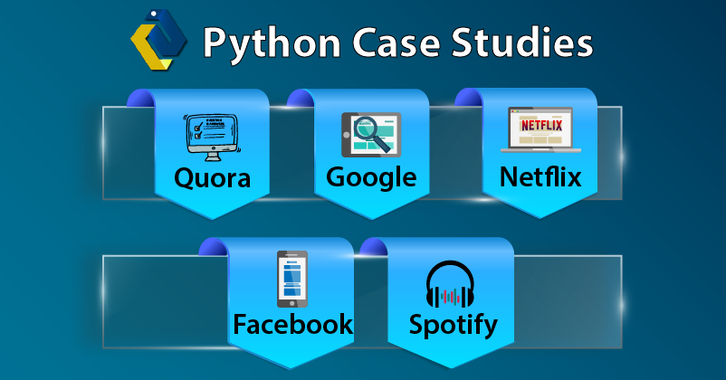

Python Case Studies
Starting with the very first Python case study that is Spotify, then we will discuss other companies like Quora, Netflix, Google, and Facebook.

Spotify
One of the music streaming giant which is using Python as its sword primarily for data analysis and backend services. It is one of the major market players and amongst top Python users. Overall backend communication takes place with the use of ZeroMQ, an open networking framework written in Python and in C++. The reason behind the choice of Python’s services is the fast development pipeline during coding. The suggestions and recommendations on Spotify largely depend upon volumes of data analytics. Hence as an interpreter for this stream of data, Spotify uses Luigi, a Python module that syncs with Hadoop. This is how Spotify also manages functions such as “Radio and Discovery”. Python handles how libraries work together and cross-check errors quickly to allow troubleshooting and redeployment. Around 6000 individual processes work together now in Spotify over the nodes of the Hadoop cluster.

Quora
So, after knowing how Spotify works using Python, now let’s move on to another Python case study that is Quora. It is a social network platform of question and answer. There was a lot of consideration before choosing Python amongst C#, Java, and Python. Lack of type checking and relative slow behavior was drawing back the interest from python. They also had reasons for not choosing other languages. They didn’t go with C# because of it’s proprietary Microsoft Language and didn’t want to put efforts to cope up with future updates to it. For Java, its strict syntax was enough to get rejected. Also, Java was a little less older in the market so there were doubts about its future growths. So the founders of Quora got inspired by Google and choose Python for its ease of writing and readability. They got rid of their initial problem of type checking by writing unit tests that accomplish the same thing. Another reason for the choice was again the good framework support that python provided, such as Django and Pylons. Having Python and JS together for handling user interactions was also a plus point.

Netflix
The use of Python by Netflix is very similar to that by Spotify. That is they rely on python for data analysis of the server-side. A significant increase in the number of users of Python in Netflix itself is because they allow their engineers to choose the language of code. They prefer the standard and third-party libraries and enjoy the extremely active community. Also, Python is so easy to develop that the developers are left with no choice other than python! The primary use of Python is in the Central Alert Gateway. This app process alerts, suppressing the duplicate ones and then route them to people that need to see them. This app has proven to a good addition to Netflix as it can give automated solutions to shaky problems such as terminating the process or rebooting. Secondly, the monkey app used to track down security and history issues has also proven to be a hit. It is also used to ensure to track dozens of SSL certificates related to Netflix’s domain.
DataFlair has published this Netflix Python Case Study in detail. Have a look – how Netflix uses Python

Facebook
This platform is an exceptional user of python because of its developer’s extensive use of the language. This is so because of the Python libraries and framework reduce the “code-load” and they can majorly focus on “actual” improvements. It is also noticed that the infrastructure of Facebook has become more scale efficient.
According to a 2016 post by Facebook, “Python is currently responsible for multiple services in infrastructure management.”
There are various Py3 written projects of Python that were published by Facebook including Facebook Ads API and a Python async IRC bot framework.
Facebook, upgrading their infrastructure and handlers to 3.4 from 2, and guess who is helping their engineers in the process – AsyncIO!

Google
Above any company, Google has been a super supporter of Python, that too from the very beginning. There decision – “Python where we can, C++ where we must” stated that python will be implemented for enabling ease of maintenance and relatively fast delivery than C++.
Some scripts which were originally written in Perl or Bash were re-coded into Python. It is now the official Google server-side language. To top it all off, Peter Norvig said:
“Python has been an important part of Google since the beginning and remains so as the system grows and evolves. Today dozens of Google engineers use Python, and we’re looking for more people with skills in this language.”

Summary
Python initially was used as a language for drafts as it was simple and cheap. But as we know that “simple is reliable” and so is python. Many companies learned it later and a lot harder way that more parts a mechanism has more mess it creates. That is why they choose python and now it covers most of the world’s popular apps built-in mechanisms. It is proved in black and white by Python that an amazing product can be backed up by simple and time-honored tools. As long as the users are satisfied with the performance, there is no loss!
Hope you liked these top Python case studies. I am sure you also want to share some more amazing Python case studies, do share them with comments.
Learn everything about Python through DataFlair’s best ever Python Tutorial Series. Save this now for FREE and you can thank me later😉

Python in Healthcare – Good Health now depends on Code too!!
Free Python courses with 57 real-time projects - Learn Python
We have always known python as an object-oriented, high-level programming language with dynamic semantics. It has attracted users from different platforms for its advantages in rapid application development and its dynamic building options. Little did we know that it is considered to be one of the “safest” programming languages too apart from all the popularity because of its functionality. Also, Python plays an important role in the healthcare sector.
Although it is tough for a normal person to believe that programming languages like Python are important in healthcare. There’s not only one reason that makes python in the limelight of healthcare. There are a number of reasons which make Python an important asset for the ones researching in the healthcare department.
Let’s explore, what is the importance of Python in healthcare and why it is considered to be one of the safest languages.
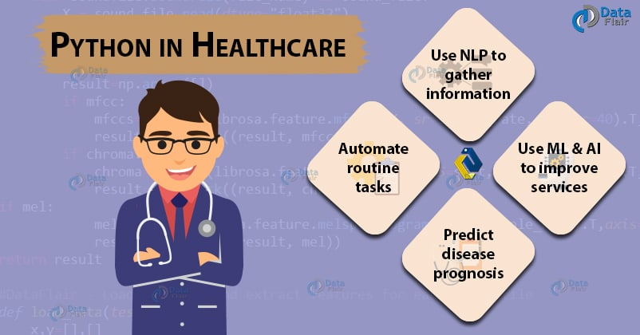
Before moving ahead in Python in Healthcare article, read a little about Python Frameworks that are Django and Flask.

Django and Flask – The Python Frameworks
The performance of Python is appreciated against abilities like meeting deadlines, quality and amount of code. To achieve the same, Python is present with a framework Django.
Its trustworthy modules are so effective that you don’t need to develop them by yourself. Also, the built-in maintenance against the web-app attack adds to its utility. Django framework allows developers to meet their requirements of any business idea related to eHealth or telemedicine projects.
There is also Flask, again a Python-based framework often used for building prototypes because of its great efficiency and can be extended to the full-stack framework with existing extensions. Its uses are still less than that of Django because it requires more time for configuration.

Why Python in Healthcare is Important?
Below are some important reasons for using Python in Healthcare sector, have a look –
- Python and its frameworks work on principles that are grounded equally and agreed upon the HIPAA checklist.
- A full look at the big data healthcare allows the organization to exchange information for seeking patient outcomes.
- The performance of the platforms made with Python is focused on their availability in phones and the web.

How Medical Startups are using Python?

Roam Analysis
Uses machine learning (artificial intelligence) and comprehensive contextual data to take over biopharmaceutical and medical device companies, that need to make decisions, suggest treatments and get the best possible patient outcomes.
Roam’s platform is powered by a proprietary data asset called Health Knowledge Graph which is continuously enriched using natural language processing to gather information and make connections with new data.
According to the official description, “Roam’s machine learning and data platform powers rich analysis of patient journeys to reveal the factors affecting treatment decisions and outcomes.”

AiCure
It is an NIH and VC-funded healthcare startup in New York. AiCure automates the process of ensuring that patients are taking their medicines, that too at their assigned time. It has combined artificial intelligence and mobile technology together.
For example, it uses computer vision to identify the patient (face recognition) and verify the right pill for the specific patient (using pill recognition) and they are actually consuming them (action recognition). They develop their backend applications using Django frameworks and use python base coding and research engineers to develop it.
Amazed by the magic of Python in Healthcare? Here are some more startups –

Drchrono
It is a software as a service patient care platform that consists of a web and cloud-based app. This American company is for doctors and patients that make electronic health records available digitally and provides management and medical billing services. This is also a phone and web concentrated platform.

Fathom Health
Again a Healthcare startup with deep learning NLP system for reading and understanding electronic health records. This startup with headquarters in San Francisco, California is backed up by Google. Their employees are familiar with Flask for API programming and data engineers prefer Python’s NLTK.

Summary
As we saw that Python is not only suitable for programming and web-based applications but it is also helpful in the healthcare sector. The Python is in the continuous development face. That is one of the major reasons why Python got such a big hand in the healthcare department. This application of Python will lead towards a better future and betterment of healthcare. Healthcare is a challenging field and Python is performing very well here.
Python role in Healthcare is just not limited here there are much more applications of Python that will lead towards a better and more high tech future. Many of us are unknown from the fact that Iron Man’s Jarvis is made up of Python.
So you must start thinking of your future in Python. As Python is the most trending language, you must start learning Python on your own to secure your future.
Happy learning 😊

Python will make you rich in the stock market!
Free Python courses with 57 real-time projects - Learn Python
There are so many factors involved in the prediction of stock market performance hence it becomes one of the most difficult things to do especially when high accuracy is required. Here data science & its techniques have been used to search patterns and insights that were not approachable before. Learning Python- object-oriented programming, data manipulation, data modeling, and visualization is a ton of help for the same. So, what are you waiting for? Read the complete article and know how helpful Python for stock market.
Stocker is a Python class-based tool used for stock prediction and analysis. (for complete code refer GitHub) Stocker is designed to be very easy to handle. Even the beginners in python find it that way. It is one of the examples of how we are using python for stock market and how it can be used to handle stock market-related adventures.
WAIT!! Already know the basics, jump to real-time project: Stock Price Prediction Project
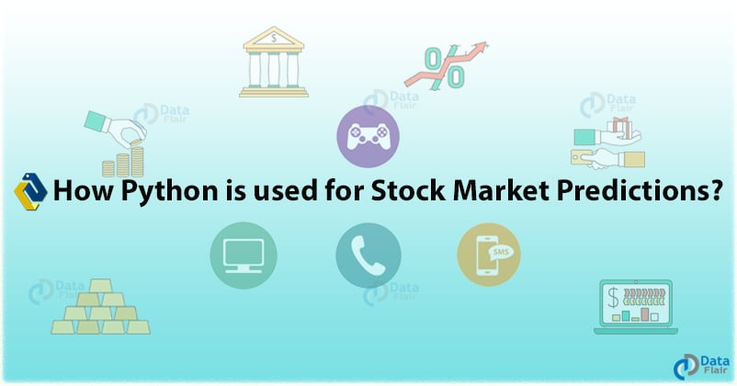

Understanding Stock Market Analysis
Stock market analysis can be divided into two parts- Fundamental Analysis and Technical Analysis.

a. Fundamental Analysis
This includes analyzing the current business environment and finances to predict the future profitability of the company.

b. Technical Analysis
This deals with charts and statistics to identify trends in the stock market.

Predicting Stock with Python
In this blog of python for stock market, we will discuss two ways to predict stock with Python- Support Vector Regression (SVR) and Linear Regression.

Support Vector Regression (SVR)
Support Vector Regression (SVR) is a kind of Support Vector Machine (SVM). It is a supervised learning algorithm which analyzes data for regression analysis. This was invented in 1996 by Christopher Burges et al. The cost function for building a model with SVR ignores training data close to the prediction model, so the model produced depends on only a subset of the training data.
SVMs are effective in high-dimensional spaces, with clear margin of separation and where the number of samples is less than the number of dimensions. However, they don’t perform so well with large or noisy datasets.

Linear Regression
Linear Regression linearly models the relationship between a dependent variable and one or more independent variables. This is simple to implement and is used for predicting numeric values. But this is prone to overfitting and can’t be used where there’s a non-linear relationship between dependent and independent variables.

Code for Stock Prices Prediction
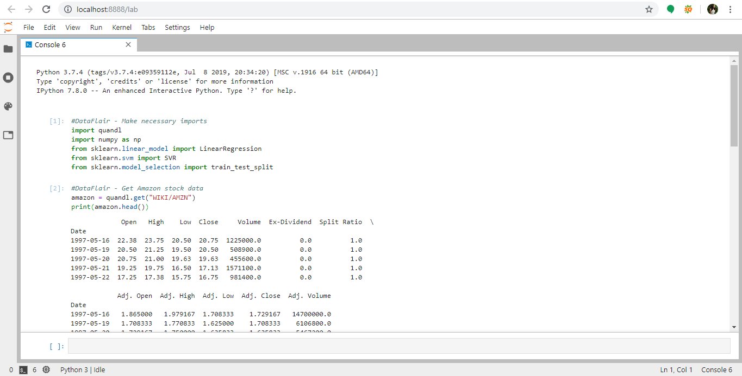
1. We will use the quandl package for the stock data for Amazon. Quandl indexes millions of numerical datasets across the world and extracts its most recent version for you. It cleans the dataset and lets you take it in whatever format you want.
#DataFlair - Make necessary imports
import quandl
import numpy as np
from sklearn.linear_model import LinearRegression
from sklearn.svm import SVR
from sklearn.model_selection import train_test_split
2. Get the Amazon stock data from quandl. Print the top 5 rows.
#DataFlair - Get Amazon stock data
amazon = quandl.get("WIKI/AMZN")
print(amazon.head())
3. Now get only the data for the Adjusted Close column. Print the first 5 rows for this.
#DataFlair - Get only the data for the Adjusted Close column
amazon = amazon[['Adj. Close']]
print(amazon.head())
4. Set the forecast length to 30 days. Create a new column ‘Predicted’- this should have the data of the Adj. Close column shifted up by 30 rows. The last 5 rows will have NaN values for this column.
#DataFlair - Predict for 30 days; Predicted has the data of Adj. Close shifted up by 30 rows
forecast_len=30
amazon['Predicted'] = amazon[['Adj. Close']].shift(-forecast_len)
print(amazon.tail())
5. Now, drop the predicted column and create a NumPy array from it, call it ‘x’. This is the independent dataset. Remove the last 30 rows and print x.
#DataFlair - Drop the Predicted column, turn it into a NumPy array to create dataset
x=np.array(amazon.drop(['Predicted'],1))
#DataFlair - Remove last 30 rows
x=x[:-forecast_len]
print(x)
6. Create a dependent dataset y and remove the last 30 rows. Print it then.
#DataFlair - Create dependent dataset for predicted values, remove the last 30 rows
y=np.array(amazon['Predicted'])
y=y[:-forecast_len]
print(y)
7. Split the datasets into training and testing sets. Keep 80% for training.
#DataFlair - Split datasets into training and test sets (80% and 20%)
x_train,x_test,y_train,y_test=train_test_split(x,y,test_size=0.2)
8. Create an SVR model now and train it.
#DataFlair - Create SVR model and train it
svr_rbf=SVR(kernel='rbf',C=1e3,gamma=0.1)
svr_rbf.fit(x_train,y_train)
9. Get the score of this model and print it in percentage.
#DataFlair - Get score
svr_rbf_confidence=svr_rbf.score(x_test,y_test)
print(f"SVR Confidence: {round(svr_rbf_confidence*100,2)}%")
10. Now, create a model for Linear Regression and train it.
#DataFlair - Create Linear Regression model and train it
lr=LinearRegression()
lr.fit(x_train,y_train)
11. Get the score for this model and print it in percentage.
#DataFlair - Get score for Linear Regression
lr_confidence=lr.score(x_test,y_test)
print(f"Linear Regression Confidence: {round(lr_confidence*100,2)}%")

Python for Stock market
Let’s look at the analytical capabilities of Stocker in parts.

Starting with Stocker
The first thing that should be done is importing the Stocker class into the current python session after installing the required libraries. You can use it to create an object. The constructed object will contain all the properties of the Stocker class. As the stocker is built on quandl WIKI database hence it allows access to 3000 and more US stocks.
Python classes are comprised of – attributes and methods. Amongst all the attributes of the class, one of it is stock data for a specific company.
The benefits of using the Python class include – the functions and the data it acts on are associated with the same object. The entire history of the stock can be plotted by using the method of the Stocker object. The ‘plot_stock’ function has a number of arguments that are optional and by default, it plots the adjusted closing price for the entire date range that can also be customized according to our needs (range, stats to be plotted, type of plot). Using ‘plot)stock’ we can investigate any number of quantities in the data present in any data range and also suggest real-world correlations.

Additive tools
These are very powerful for analyzing and predicting time series. We know that the long term trend of any established multinational company seems to be increasing in nature but there is a possibility of identifying yearly or daily basis patterns. Such help of time series with daily observations can be provided by Prophet, developed by Facebook. Stocker can do all the work that be done by Prophet behind the scenes using simple method call to create and inspect the model.
These types of models remove disturbance present in data and smoothen it. Prophet models also look into fluctuations of data in real-life processes and make predictions for the future. Though there is concern related to past data but future data analysis is what companies strive for. This method call returns two objects (data and model) which are then assigned to variables that are later on used to plot time series components.
Explore top Python Applications to know more about the use of Python

Changepoints
It occurs when the time-series go from increasing to decreasing or vice-versa. These patterns are also very important as one needs to know when the stock rate is at its peak or there are significant economic benefits. Identifying these points and their cause of change helps in predicting the future. The stocker object can automatically predict the 10 largest changepoints which tend to line up near the peaks and valleys of the stock price graph (generally). On the other hand, the prophet can only find changepoints in the first 80% data only. Google search tools allow us to see the popularity of any search word over time in Google searches. Stocker can automatically retrieve this data for any specific term.
These are only the first half capabilities of the stocker where Python for stock market is used. The second half –

Predictions
They are designed for forecasting, or predicting future prices. This is a tiresome exercise and hence needs plenty of learning to get into the actual process. The capabilities are publically available, even creating the tool itself.

Summary
We live in an age where anyone can learn programming or arts like data science or machine learning without that much of formal instructions. The idea can be anything, even stock prediction, python can be used in any sort of application base. All you need is hands-on knowledge of it!

Coffee-Python-Popcorn-Netflix! (how Netflix is using Python)
Free Python courses with 57 real-time projects - Learn Python
The next time you’re streaming on Netflix, while you are thinking what to watch next please do take a minute to thank popular programming language Python and the developers who use it for much of the experience.
Netflix – This internet entertainment giant is a huge proponent of Python, using the language primarily for data analysis and back end services. It allows their software engineers to choose what language to code in, and have noticed a large upsurge in the number of Python applications.
Quoting the Python developers at Netflix, “the language is used through the “full content lifecycle”, from security tools to its recommendation algorithms, and its proprietary content distribution network (CDN) Open Connect”
Python at Netflix.
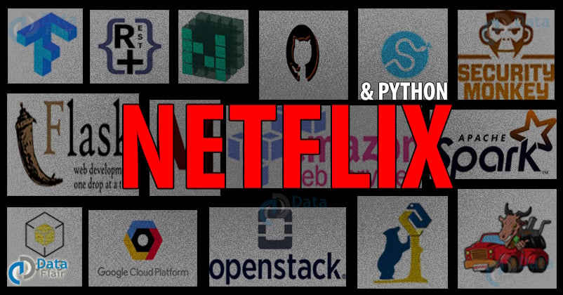

How Python is helping Netflix to grow

Open Connect Network
Actually, it is imprecise but still, thinking about Netflix infrastructure, it is everything that happens before you press Play on your remote control!
What plan do you have? what have you watched so we can recommend new titles to you? or what do you want to watch? takes place in Amazon Web Services (AWS), whereas everything that happens afterward i.e., video streaming takes place in the Open Connect network.
The network devices that are fundamental for a large portion of the CDN are managed by Python applications. Applications track the inventory of network gear: what devices, of which models, with which hardware components, located in which sites.
“We are proud to say that our team’s tools are built primarily in Python,” the team writes.

Demand Engineering
Netflix’s demand engineering team brings flexibility into the network by introducing regional content and balancing the distribution of Netflix’s traffic.
Certain types of tools give Netflix a strong front stand are — Numpy and Scipy for numerical analysis, Boto3 for AWS infrastructure, rq for running asynchronous workloads, Flask APIs are used as a wrapper around the synchronization tools above.
Netflix uses Python to build custom extensions to the Jupyter server that allows engineers to manage tasks like logging, archiving, publishing and cloning notebooks.

Core
Meanwhile, the big data synchronization team provides services and tools for scheduling. There are usually thousands of signals after an alert which wait for their analysis. To aid this Netflix’s CORE team uses many Python statistical and mathematical libraries that again include Numpy, Scipy, ruptures, and Pandas. On top of that, Python is also typically used for automation tasks, data exploration and cleaning, and visualization.
Learn about Python Libraries in detail in just 7 mins

Insight Engineering
This was all about the main “Demand engineering”. Except this, there is an Insight Engineering team. It is responsible for building and operating the tools for operational insight, alerting diagnostics, and auto-remediation. As the demand for Python is increasing at this pace, the team supports Python clients for most of their services. The Python frameworks Gunicorn, Flask, Flask-RESTPlus were also used to create Netflix’s Winston and Bolt diagnostic and therapeutic platforms.

Information Security
To name a few high leverage goals for Netflix: security automation, risk classification, auto-remediation, and vulnerability identification — all accomplished using Python. One of the most active open-source projects- security monkey. It is used for monitoring AWS, Google Cloud Platform, OpenStack, and GitHub for applying changes to assets. Repokid allows the use of Python for helping with IAM (Identity and Access Management) permission tuning. Whereas Lemur is used to help generate TLS certificates. Netflix also uses the Diffy forensics triage tool, which is built entirely using Python.

Machine Learning Infrastructure
All the machine learning training models from recommendation algorithms to artwork personalization to marketing algorithms, Netflix relies extensively on all of these in Python. Many applications are powered by Metaflow, a Python framework that makes it easy to execute ML projects from the first model to the final product. CPU cores, millions of computational tasks and handling hundreds of millions of data points in memory, Netflix depends on Python code for fetching it.
Learn everything about Machine Learning at a single place – Free 100+ Machine Learning tutorials

Notebooks
Many of the components of the balancing service are written in Python. Starting with scheduler, which uses Jupyter Notebooks with papermill to provide molded job types like Spark. This allows users to have an easy way to express work that needs to be executed.
Internally, there are event-driven platforms that are fully written in Python. It helps in defining conditions to filter events, and actions to react or route them. As a result of this, microservices are segregated and visibility is provided into everything that happens on the data platform.

Partner Ecosystem
The Partner Ecosystem group is expanding its use of Python for testing Netflix applications on devices. Python is the core of a new CI infrastructure, including balancing servers, controlling Spinnaker, test case querying and filtering, and scheduling tests run on devices and containers. The additional post-run analysis is being done in Python using TensorFlow to determine which tests are most likely to show problems on which devices.

Netflix Animation and NVFX
Python is the industry standard for all of the major applications used to create Animated and VFX content. All of the integrations with Maya and Nuke are in Python, and the bulk of Shotgun tools are also in Python. Netflix is also getting hands-on tooling in the cloud, and anticipate deploying many of their custom Python AMIs.
The reason that the services are written in Python is due to the extremely active development community, and the rich variety of third-party libraries available to solve nearly any given problem.
Not only Netflix but many major companies are also using Python. What are you waiting for? When will you start using it? Start learning Python by Yourself NOW!!

Conclusion
Netflix, being a $12 billion earmarked entertainment company with over 148 million paid memberships in over 190 countries which enjoy TV series, documentaries and feature films across a wide variety of genres and languages. So you can watch as much as you want, anytime, anywhere, on any Internet-connected screen. You can play, pause and resume watching, all without any commercial or any commitment!
Hope you liked the article. Share your feedback through comments.

